## License

To give rights to use a specific part of the software, NavVision uses licenses to open up these parts of the software. Depending on which licenses are bought, viewers will be visible and strings will be processed (see Figure 2‑13).

Under “License” you can see which viewers, communication etc. are opened in your version. If you see a license and it is green, this means that the license is valid. If the license is red it is not valid. If there is no license and the stripes in the box are green or red it means the same, only than the license is freed up by another license (i.e. Navigation Pro license will also open up NMEA, so the stripes under NMEA will be green).

Normally you won’t have to alter anything here. Free Technics will provide you with a “Key.uc.ini” with all the necessary licenses available. The program will read the licenses from the ini-file and put them in place at startup. Sometimes however you can check here if you miss a certain viewer or if a communication protocol doesn’t seem to work. If you are missing a single license, you can fill it in here and it will be set in the ini-file as well.

*: Missing licenses are also mentioned in the logbook. Please refer to the chapter “Logbook” for more information.*

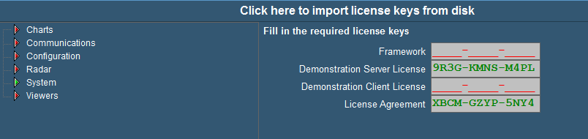

Figure 2‑13: License